EESM5547 Project 1 Report

Project Name: Compression of Point Cloud

Team Member:

Huang Jingye （20294683）

Li Bin（20296588）

Suo Zihan（20305731）

Liu Qingyu（20297037）

Contents

1. Introduction................................................................................................................3

2. Compression Methods................................................................................................3

2.1 DCT.......................................................................................................................3

2.2 Random Sampling.................................................................................................5

2.3 Predictive Coding..................................................................................................6

2.4 Chord height error algorithm based on slicing......................................................8

3. Compression Comparison..........................................................................................9

4. Conclusion..................................................................................................................9

5. Workload..................................................................................................................10

1. Introduction

A point cloud is a set of data points in some coordinate system. Point cloud has potentially higher compression ratios. In this project, four compression methods(DCT, Random sampling, Predictive coding,) were used to compress four point cloud data sets　(Chef, Kangaroo, Trex and Chicken). After completing the compression, the data may have various distortion or loss.

At last, we will make a comparison among all the methods and find out the one which has the best compression effect.

2. Compression Methods

2.1 DCT

Discrete cosine transform (DCT) expresses a finite sequence of [data points](https://en.wikipedia.org/wiki/Data_points) in terms of a sum of [cosine](https://en.wikipedia.org/wiki/Cosine) functions oscillating at different [frequencies](https://en.wikipedia.org/wiki/Frequency). It transforms a signal or image from the spatial domain to the frequency domain.

In this project, we encoded the data sets using DCT first. Then we discard the less important frequencies. The most important frequencies that remain will be used to retrieve the original data sets(using IDCT).

Original data sets

Apply DCT and get a matrix expressing data in frequency domain

Discard high frequency part

IDCT and reconstruct the data

Make a comparison with the original data set

Figure 2.1 DCT method process

Use 'trex.dat' data set as an example, the original data set is a 38776*3 matrix. The output plot in 3D is shown in figure 2.2.

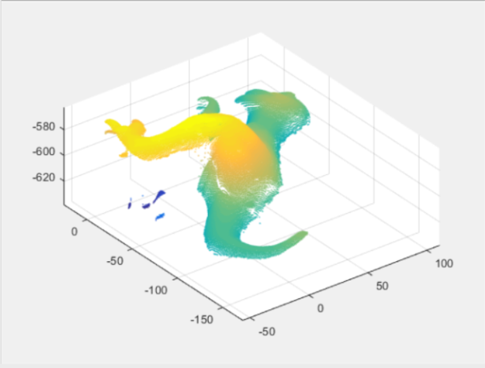

Figure 2.2 Original trex.dat output plot in 3D

After transform the original data set using DCT, we get a new 38776*3 matrix expressing the data set in frequency domain. In this project, we decide to discard the high frequency factors which appear in the lower part of the matrix. Then we apply IDCT to the new matrix and get the compressed data set. The result is shown as figure 2.3:

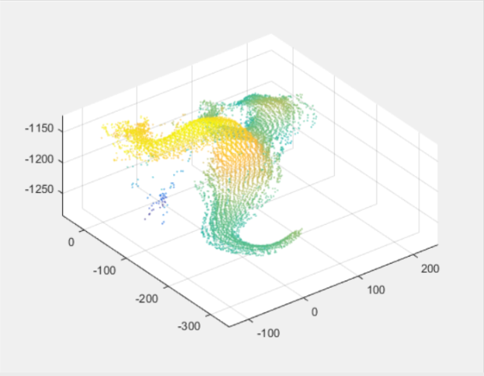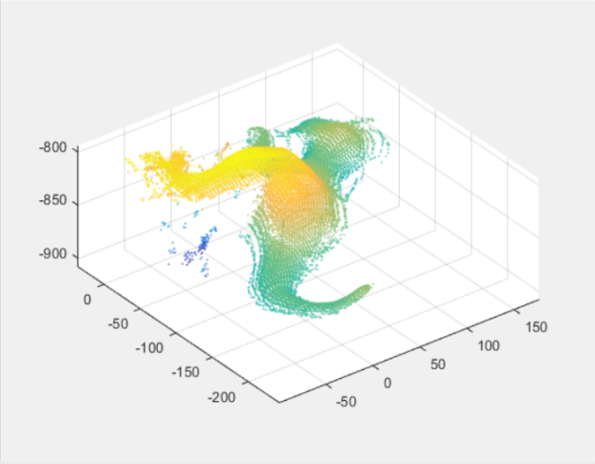

(a)Discard 29082 rows in the lower part (b)Discard 19788 rows in the lower part

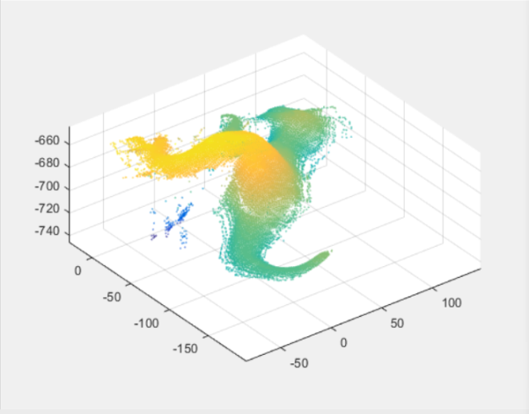

(c)Discard 9694 rows in the lower part

Figure 2.3 Compressed output plot using DCT

Related details of compression effect are shown as follows:

Table 2.1 DCT compression result

|  |  |  |  |
| --- | --- | --- | --- |
|  | a | b | c |
| Original size | 1894KB | 1894KB | 1894KB |
| Processed size | 474KB | 947KB | 1420KB |
| Compression rate | 0.25 | 0.5 | 0.75 |
| Complexity | 0.0849s | 0.3034s | 0.6852s |

In DCT compression method, the compression rate is variable and it depends on the data we discarded. However, in order to keep a low distortion, it is believed that compression rate should be higher than 0.5.

2.2 Random Sampling

Random sampling is a method which discards the data points randomly selected. This method is easy to process. But it may cost high data loss when the discard data points are in a large amount. Random Sampling process is shown as Figure 2.4:

Original data set

Select a certain amount of data point randomly

discard these points

Get the results of Random Sampling

Figure 2.4 Random Sampling Process

The result of random sampling is shown as Figure 2.5:

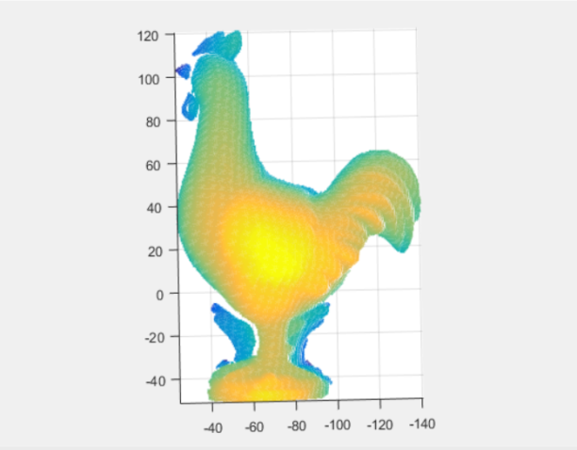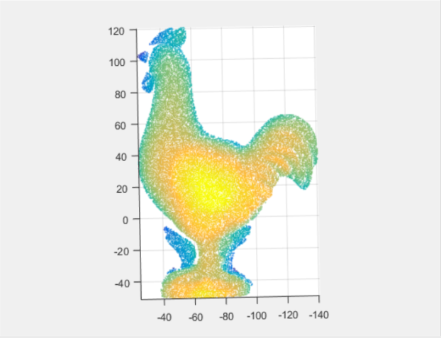

(a)Original chicken.dat output plot in 3D (b) Randomly discard 10000 points

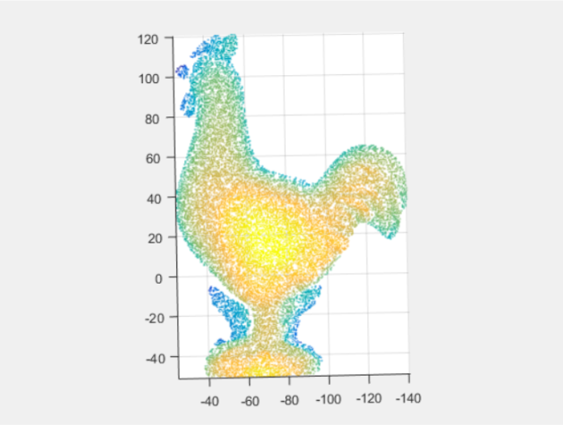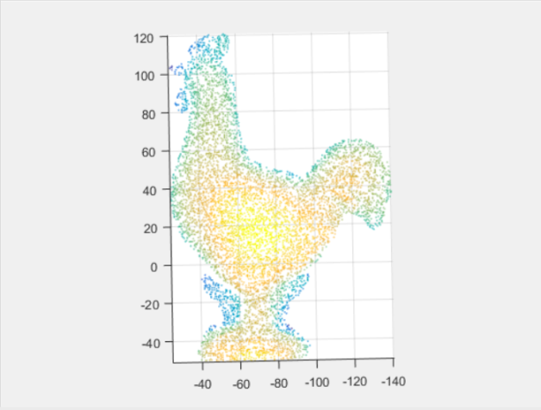

(c)Randomly discard 20000 points (d)Randomly discard 25000 points

Figure 2.5 Random Sampling compression output plot

Compression Effect of Random Sampling is shown as follows:

Table 2.2 Random sampling result

|  |  |  |  |
| --- | --- | --- | --- |
|  | a | b | c |
| Original size | 1442KB | 1442KB | 1442KB |
| Processed size | 954KB | 465KB | 221KB |
| Compression rate | 0.6612 | 0.3224 | 0.1531 |
| Complexity | 0.0072s | 0.0105s | 0.0117s |

Cause we deleted points from original point cloud, we cannot calculate MSE here. However, we can distinguish the online of the image with out eyes. The detail of the image keep losing when the compression rate increase.

2.3 Predictive Coding

For data compression we can also use predictive coding. Predictive coding is an attempt to predict the value of a data point based on the values of the surrounding data points. In this project, we use the last data point value to predict next data point value. In other words, we need to get the error matrix first. Then we do quantization based on the error matrix for the purpose of compression. Related details are shown as figure 2.6 and the results are shown as figure 2.7:

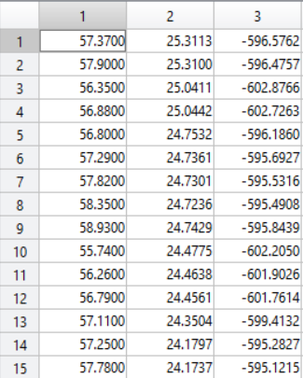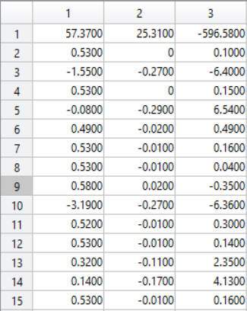

trex.dat data set error matrix after quantization

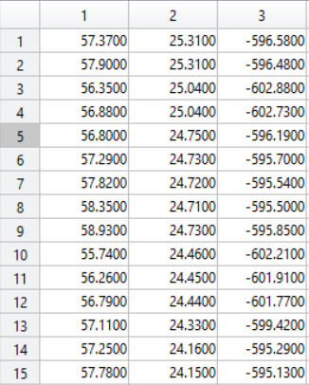

Retrieved data set

Figure 2.6 Predictive coding process

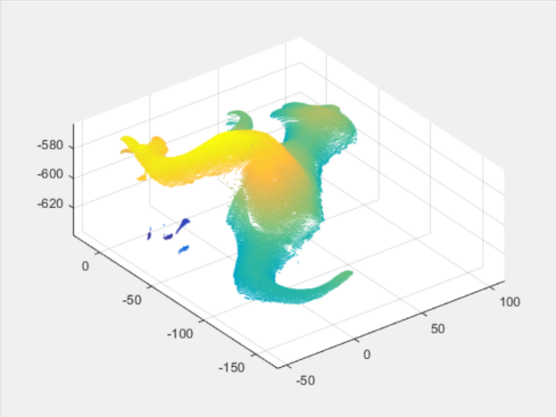

Figure 2.7 Predictive coding & Quantization output plot

Compression ratio of predictive coding = 0.6898

MSE of predictive coding = 2.9513

Complexity of predictive coding = 0.7706s

2.4 Chord height error algorithm based on slicing

This method is a high-efficiency data reduction method. It is based on slicing technology. It divided the space into 10 domains based on z dimension. For the points laying in each domain, we will sequence every point in the plane based on the value of x axis. On the basis of the sequence, we can calculate the vertical distance between one point and its two adjacent points. If the vertical distance is greater than threshold which we set, then we retain this point. Otherwise we will discard it.

The result of this method is shown as Figure 2.8:

In our project, first, we calculate the average value of chord height error algorithm based on the particular 3D point cloud picture. Then, we design the threshold based on the average number. The code is given below:

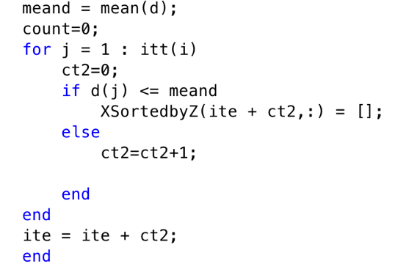

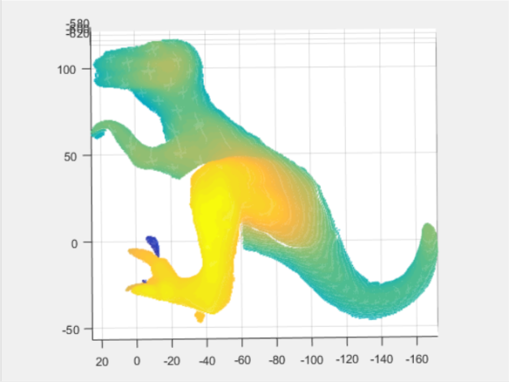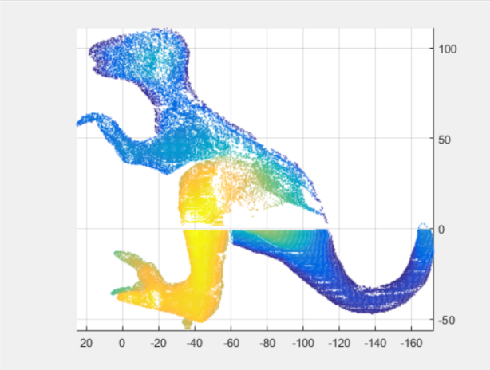

(a) The original output plot (b) Threshold=1 output plot

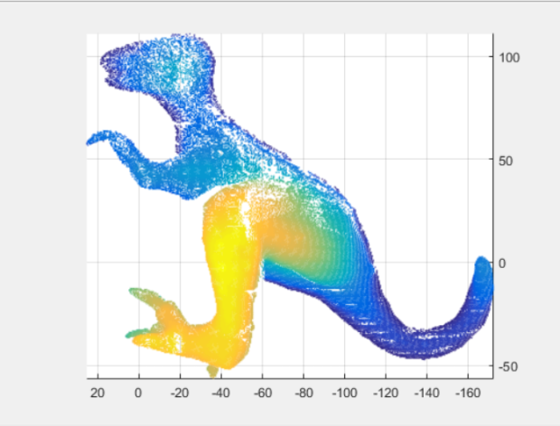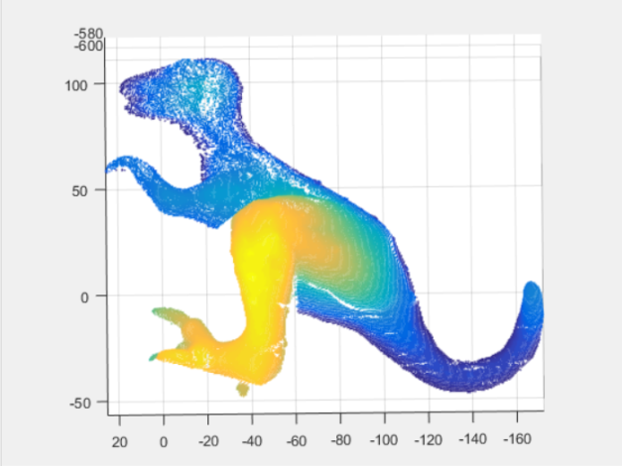

(c) Threshold=0.75 output plot (d) Threshold=0.5 output plot

|  |  |  |  |
| --- | --- | --- | --- |
|  | b | c | d |
| Compression rate | 0.6295 | 0.7382 | 0.8073 |
| Complexity | 0.2016s | 0.2216s | 0.2507s |

In this algorithm, N and di affect the result of compression. We can tell from the result, when N and di are high, the compressed image lost lots of useful points. We can hardly tell the image after compression. But, when we choose appropriate N and di, the result is good enough to distinguish.

3. Compression Comparison

Due to the variability in compression rate of DCT method and Random Sampling method, we make the comparison of these three methods in a fixed compression rate(around 0.6898). The details are shown as table 3.1:

Table 3.1 Compression comparison

|  |  |  |  |  |
| --- | --- | --- | --- | --- |
|  | DCT | Random Sampling | Predictive Coding | Chord height error algorithm based on slicing |
| Compression Rate | Around 0.6898 | | | |
| MSE | High distortion | Low distortion | 2.9513 | Low distortion |
| Complexity | 0.6122s | 0.0070s | 0.7706s | 0.2100s |

4. Conclusion

According to the results we got, DCT method has the highest MSE and high complexity. Random sampling has the shortest processing time but it may cause loss of important data. Predictive coding has the lowest MSE but also has the highest complexity. Chord height error algorithm based on slicing method has low distortion and the complexity is slightly high.

With the same compress rate, as for complexity index (running time), random sampling is the optical compression method.

5. Workload

5.1. Discuss which coding methods to be used—Liu Qingyu, Huang jingye, Li Bin.(2 hours)

5.2DCT coding and debugging---Liu Qingyu, Huang jingye, Li Bin, Suo Zihan (6 hours)

5.3 Random sampling coding and debugging---Liu Qingyu, Huang jingye (4 hours)

5.4 Predictive coding and debugging---Liu Qingyu, Huang jingye (5 hours)

5.5 DWT coding and attempting---Suo Zihan, Liu Qingyu (2 hours)

5.6 OcTree coding and attempting---Li Bin, Liu Qingyu (2 hours)

5.7 Chord height error algorithm based on slicing ---Liu Qingyu, Suo Zihan (2 hours)

5.8 Data collecting and reorganization—Suo Zihan, Huang Jingye (2 hours)

5.9 Presentation preparation and editing--- Suo Zihan (3 hours)

5.10Final report preparation and editing---Huang jingye, Li Bin (3hours)

5.1 Li Bin—Discuss which coding methods to be used and edit DCT, DFT, OcTree coding, and get graphic results of DCT, prepare final report.

5.2 Liu Qingyu--- Discuss which coding methods to be used and edit DCT, Random sampling, Predictive coding, slicing coding and get graphic results.

5.3 Huang Jingye--- Edit DCT, Predictive coding, Random sampling coding and get graphic results, prepare and reorganize final report.

5.4 Suo Zihan---Discuss which coding methods to be used and edit DCT, DWT coding, collect and reorganize data, prepare final presentation.